Troubleshooting Guide

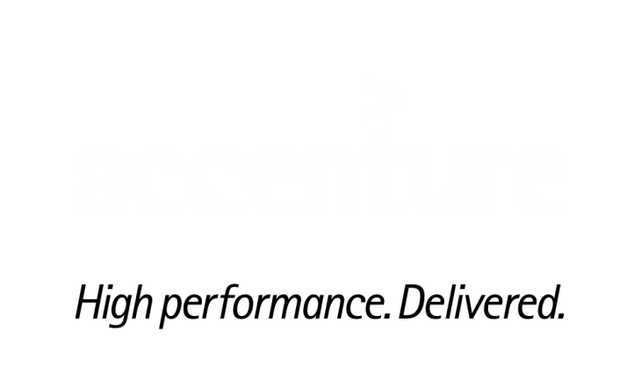

**Troubleshoot General outlook issues**

Contents

1. Outlook Rules Issues 3

2. PhishMe Button Disappears from the Menu Bar 3

3. Auto-Complete Add-in disabled 5

4. Auto-Complete Corruption 6

5. Auto mail forwarding Request 8

6. Office account Inactive 9

# Outlook Rules Issues

Users may encounter inbox rules synchronization issue wherein some rules are not seen from either Outlook or OWA. There are also instances where some rules affect the other rule resulting to an issue on its function or when rules are corrupted.

**Steps to fix the Issue**

1. Rules can also be recreated but first, perform below steps:
2. Export Rules
   1. On the Tools menu, Under Rules Drop Down Click on Manage Rules and Alerts.
   2. In the Rules and Alerts dialog box, click Options.
   3. In the Options dialog box, click Export Rules. Note the location where you save the rules.

*Note: Once export is finished, press Window” Key + R run* ***outlook.exe /cleanrules****. Then user can recreate the rules or import the rules.*

1. Import Rules
   1. On the Tools menu, click Rules and Alerts.
   2. In the Rules and Alerts dialog box, click Options.
   3. In the Options dialog box, click Import Rules and try to run them
   4. If the issue is still not resolved, please raise a case with M&C (SNOW group MSGCOLLAB-O365-OPER)

# PhishMe Button Disappears from the Menu Bar

The issue here is Phish Me button disappears from the menu bar in the outlook.

**To fix the issue:**

* Check if the PhishMe Reporter add-in in installed by going to Outlook – File- Options- Add-ins:

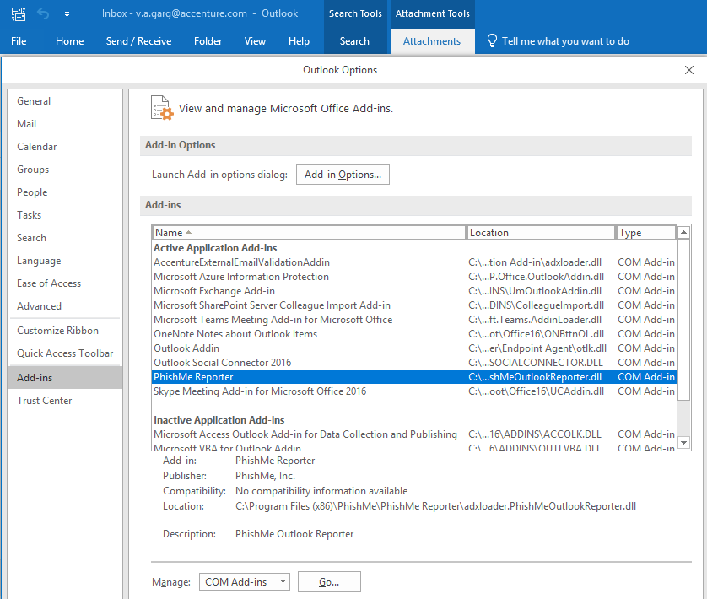

If the add-in is installed and still the button is missing, click on Go button from the above screen and check if PhishMe Reporter is checked. If not please check the same.

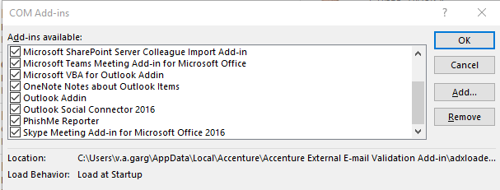

In case if the PhishMe is add in is not installed in the system follow the steps mentioned in the link below:

<https://in.accenture.com/mycomputer/manually-install-and-disable-phishme-add-in-for-outlook/>

If the issue persists, raise a case Workstation team (SNOW group WKSTNSVS-SW-GLOBAL).

# Auto-Complete Add-in disabled

Some users may encounter an issue wherein the Auto-Complete option is greyed out in Outlook as seen from the screenshot below. This is because of the Group Policy applied on user’s system.

If Auto complete not works, name will not resolve automatically, each and every time we have to pick the name from address book.

​By default, Auto Complete Option is enabled for all users. It might be disabled due to user or machine policies.

Error screenshot

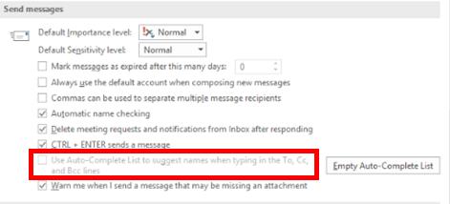

**Steps to fix the Issue**

​If user is a part of the AD group 'Procurement_Security_Global', they would have AutoComplete disabled in Outlook.

1. Access <https://directory.accenture.com/WebAdmin/search.aspx> , Under search for groups, you can type in the AD group
2. Once the data populates click on “ Display Complete User and Subgroup Membership” as shown below and search for the impacted user ID if it exists.

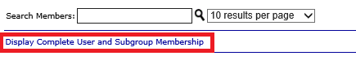

To narrow down, whether it is a machine or user policy, we can configure user's outlook on working user's windows profile. If it works, the issue with user's windows profile policy, otherwise it is a machine policy.

# Auto-Complete Corruption

Every time you send a message, the recipients are stored in a cache known as the Auto-Complete List. The next time you start to type those names in the To, Cc, or Bcc boxes, the Auto-Complete List suggests names in your cache that are possible matches. This saves time when you're addressing messages.

But sometimes names in the cache aren't needed any longer. Maybe you wanted to send a message to someone just once or twice, or to send messages to somebody else with a similar name or sometimes an NDR like below is generated when the autocomplete entry gets corrupted. When this happens, you might want to remove one or more recipient names from the Auto-Complete List.

**NDR generated**

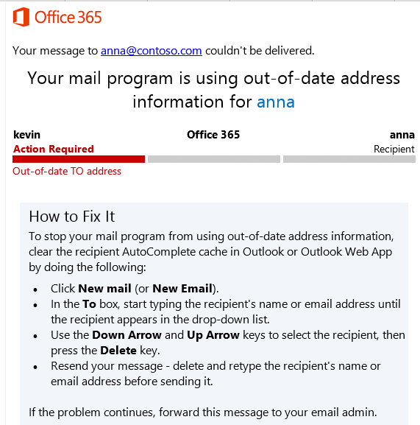

Remove a suggested name or email address from the Auto-Complete List by following the steps below

1. Sign in to Outlook/outlook Web App
2. Create a new message, and in the To, Cc, or Bcc lines, start typing part of the name you want to remove from the Auto-Complete List.

**From OWA(webmail):**

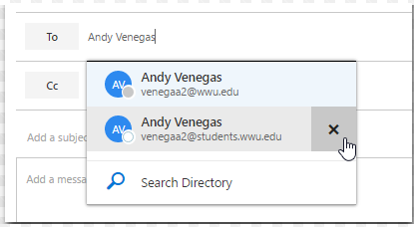

**From Outlook:**

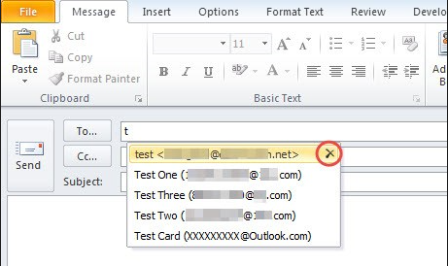

1. If the entry you want to remove is highlighted, choose Delete (click on “X” mark). If the entry you want to delete isn't selected, use the Up Arrow or Down Arrow to navigate to the entry you want to delete, and then choose Delete.
2. Try sending email afresh by typing the complete ID
3. If the issue is still not resolved, please raise a case with M&C (SNOW group MSGCOLLAB-O365-OPER)

# Auto mail forwarding Request

User may come up with a request saying he/she wants to forward some or all emails to other account (Internal/External) or complaint that email forwarding is not working as expected.

**Setting up email forwarding request (Internal Only)**

User wants to setup email forwarding to some other Internal ID (Accenture ID’s). User can automatically forward or redirect his/her email messages internally by setting up Inbox rules in Outlook or on the web.

**Using OWA:**

1. In Outlook Web App, click **Settings Settings icon > Options > Mail> Inbox Rules.**
2. On the Inbox rules tab, click the arrow next to the plus symbol +, and select **Create a new rule for arriving messages.**
3. Under When the message arrives, select **Apply to all messages**.
4. Under Do the following, click More options.
5. Under Do the following, **select Forward, redirect or send**, and then **select Forward the message to or Forward the message as an attachment to.**
6. Select the address you want your mail sent to by double-clicking it in the address book view. If the address you want to forward to doesn't appear, you can enter the email address on the To line at the top of the window.
7. Click OK to save your selections and return to the new rule window.
8. Click Save to save your rule and return to the Inbox rules tab.

**Using OUTLOOK:**

1. **Click File** on the top left of Outlook's main page. This brings up Outlook's settings panel.
2. **Click "Manage Rules & Alerts"** in the Account Information panel to bring up the Rules and Alerts window.
3. **Click New Rule at the top left corner** of the Rules and Alerts window. This brings up a Rules Wizard window.
4. **Select "Apply rule on messages I receive"** under the Start from A Blank Rule section. **Click Next.**
5. **Select your desired conditions**. If you want to forward all emails from a person or group of people, check the box next to "From People Or Public Group". If you want to make sure you get important messages, check the boxes next to "Marked As Importance" and "Flagged For Action"
6. **Click on underlined links** to specify rule descriptions
7. **Enter value for condition.** In this example, we want to forward all mail that comes from the hypothetical group "laptop". If the address is already stored in your address book, you can search for it. Otherwise, type the email address(es) into the From field. **Click Ok**

7A**.**If you've selected an email address that is a group, Outlook will advise that you choose to receive emails that are sent to that group rather than emails sent from it to avoid getting too many unnecessary messages. **Click No** if you want to make sure that emails sent from anyone in that group will get forwarded.

**Select "Forward It To People Or Public Group"**for messages that meet the condition.

1. **Click the underlined words** in the descriptions to specify where the messages get forwarded.
2. **Enter the email address** where you want your messages forwarded.**Click Ok.**
3. **Create exceptions** to filter out messages that are not important. For instance, if an email has the word "Promotion" or "Advertisement" in the Subject line, you may choose to not forward it.  You may choose to skip this step. **Hit Next** when you're done.
4. **Name your rule** and **check to see that your settings are correct**. You can choose to apply the rule to existing messages in your inbox to forward all existing email from your chosen group to your email address. If everything is in order, **click Finish.**
5. **Click Ok** in the Rules and Settings window to apply your new rule.

**Note**: The user can also be guided/assisted by a local workstation support for ease of implementing the above steps.

**Setting up email forwarding request (External Only)**

When user wants to setup email forwarding to other external ID’s (Non- Accenture ID’s)

This is not a listed standard process and we are bypassing the security as we would be sending all emails to an external ID not managed by Accenture, so this requires a security exception, please have one raised at [https://egrc.accenture.com/apps/ArcherApp/Home.aspx#home](https://egrc.accenture.com/apps/ArcherApp/Home.aspx)  and once the request is approved provide it in the pdf format for implementation and assign incident to **MSGCOLLAB-O365-OPER**.

# Office account Inactive

Some users may complain that they are not able to activate the Office package for their ID

Common errors look may like below

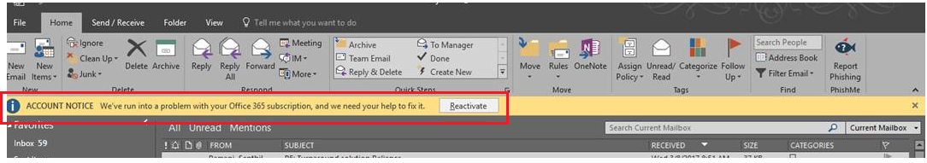

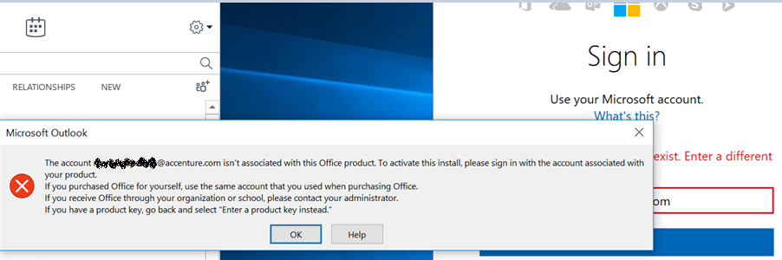

Please work with local tech support or IAM team who would help reset Microsoft Office License/Azure license to the end user.